UML – Activity Diagrams

Project: EasiLendar

The Very Best Meeting Planer

Creator: Dung Ngo

Last update: 11/05/2015

Table of Contents

I. Sign in Activity diagram 5

1. Login diagram 5

2. Register 6

3. Forgot password 7

II. Search Activity Diagrams 8

1. Search 8

2. Send requests 9

3. View profile 10

1. View detailed event 11

III. Appointment Activity Diagrams 12

1. Choose person who you want to meet. 12

2. Common Filter 13

3. Advance Filter 14

IV. To-do Statechart diagram 15

1. Main diagram 15

2. Important, Very Important, Recently diagram 16

3. Done list diagram 17

4. Checklist diagram 18

V. Sync Activity diagram 19

1. Facebook 19

a. Log in 19

b. Log out 20

c. Update events 21

2. Local: Update Events 22

3. Google 23

a. Log in 23

b. Log out 24

c. Update Events 25

VI. Share Activity diagram 26

1. Facebook 26

a. Share 26

b. Send Message 27

c. Log out 28

VII. Sign Out Activity diagram 29

VIII. Refresh Activity diagram 30

IX. Exit Activity diagram 31

X. Calendar Activity diagram 32

1. Calendar Menu 32

a. Change Calendar 32

b. Go to Today 33

c. Search 34

d. Create new events 35

2. Day Calendar 36

a. Change day 36

b. View event detail 37

3. Month Calendar 38

a. Change month 38

b. View event detail 39

c. Table of all months in year 40

d. Create new event 41

4. Week Calendar 42

a. Change week 42

b. View event detail 43

5. List Calendar 44

a. Draw week 44

b. Create new event 45

c. View event detail 46

XI. Edit Event Activity diagram 47

XII. Notification Activity diagram 48

1. Friend Tab 48

2. Request Tab 49

3. Respond Tab 50

XIII. Friend Panel Activity diagram 51

1. Appointment, Delete and View Profile 51

2. Sort friend list 52

3. Search friends and Refresh friend list 53

XIV. Result Activity diagram 54

1. Change week 54

2. See other results and view result detail 55

3. Back to edit or save results 56

XV. Profile Activity diagram 57

1. View Profile 57

2. View Calendar 58

3. View Information 59

4. View Friend List 60

5. Date, Delete, Add and Chat 61

# Sign in Activity diagram

## Login diagram

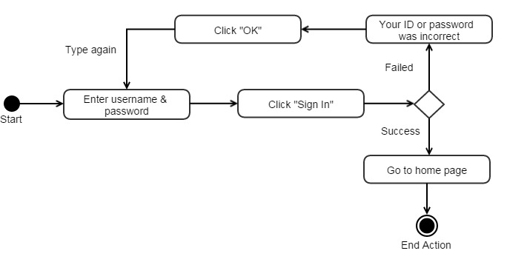

## Register

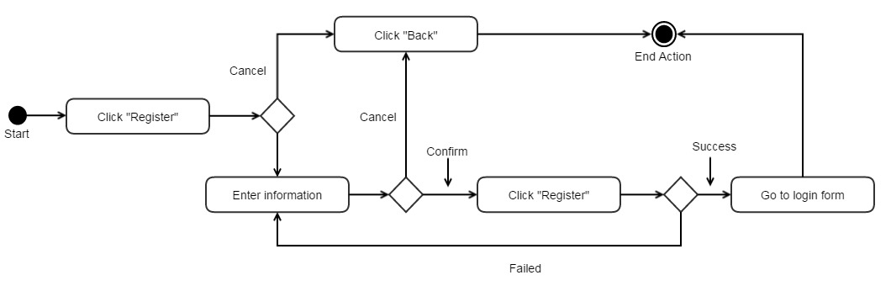

## Forgot password

# Search Activity Diagrams

## Search

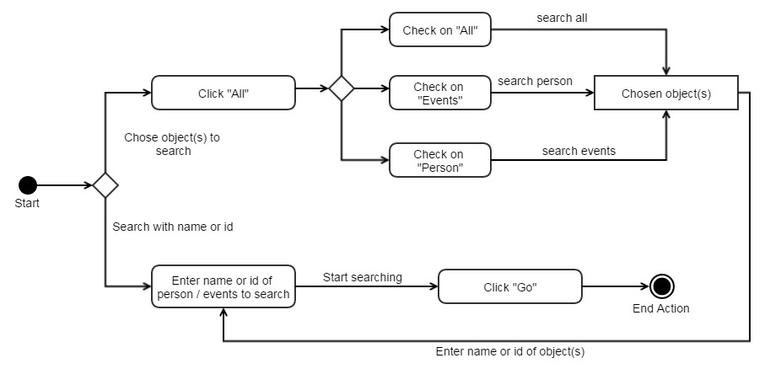

## Send requests

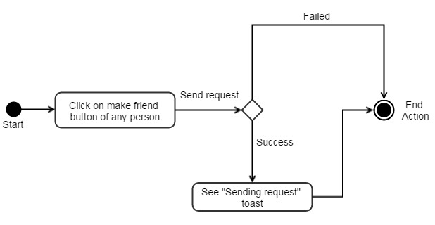

## View profile

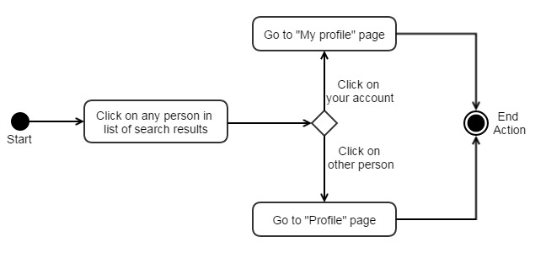

## View detailed event

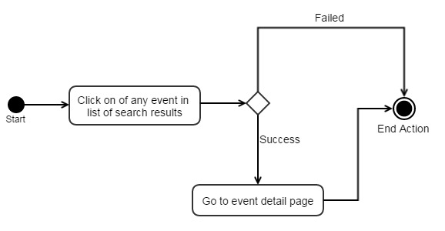

# Appointment Activity Diagrams

## Choose person who you want to meet.

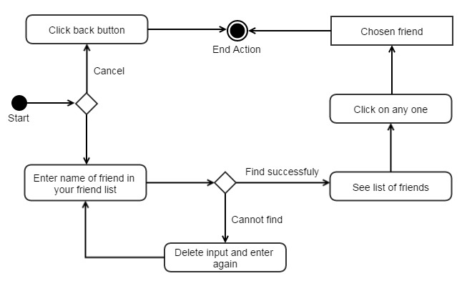

## Common Filter

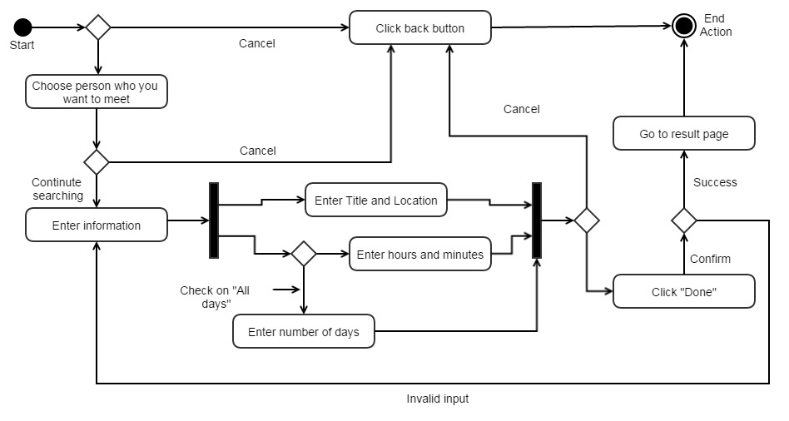

## Advance Filter

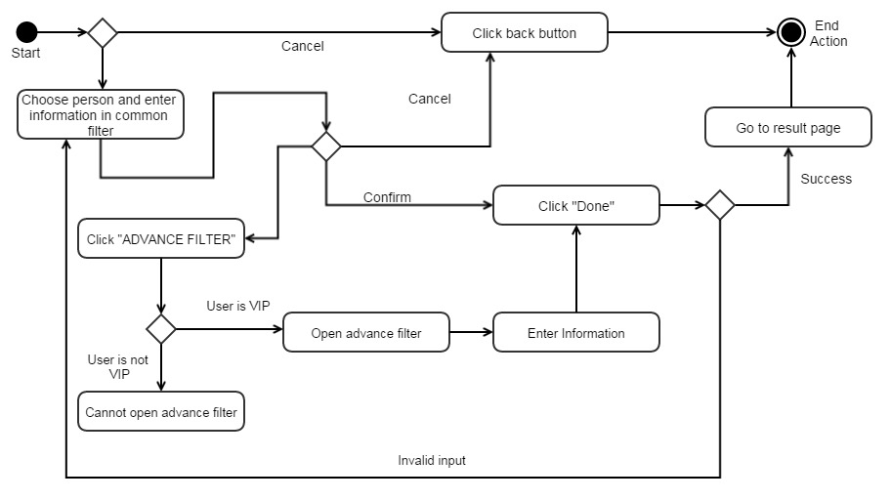

# To-do Statechart diagram

## Main diagram

## Important, Very Important, Recently diagram

## Done list diagram

## Checklist diagram

# Sync Activity diagram

## Facebook

### Log in

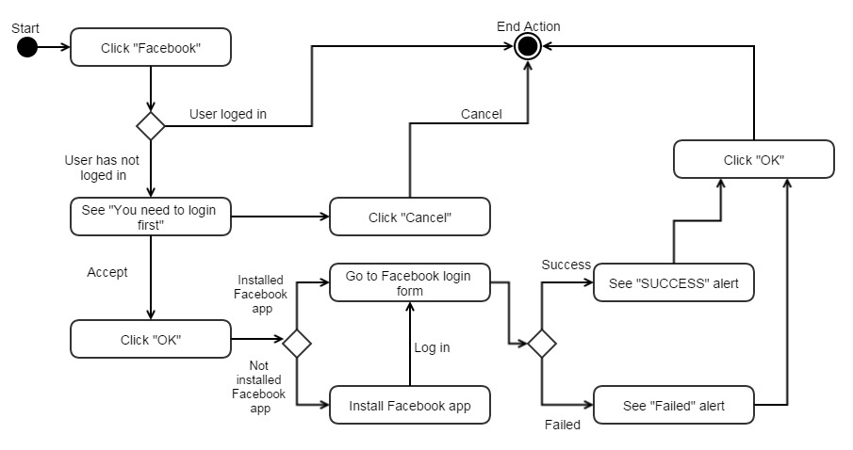

### Log out

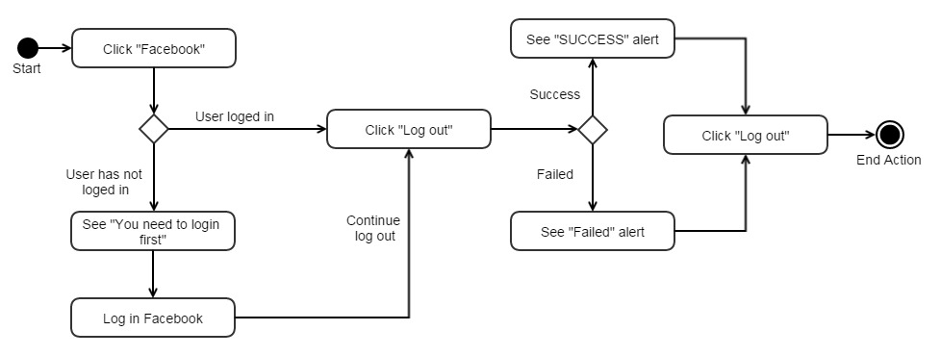

### Update events

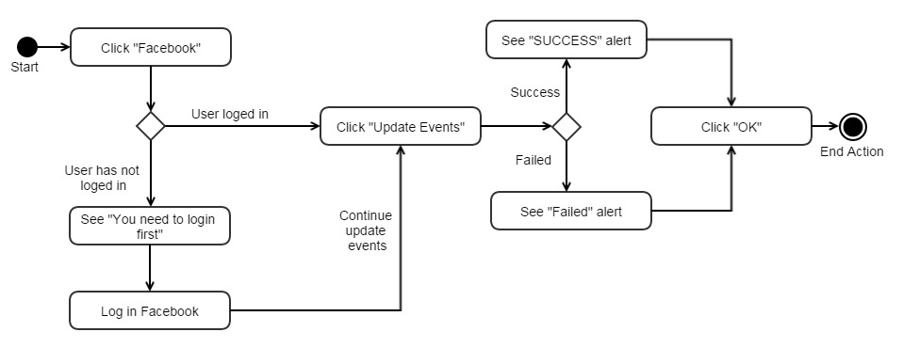

## 2. Local: Update Events

## Google

### Log in

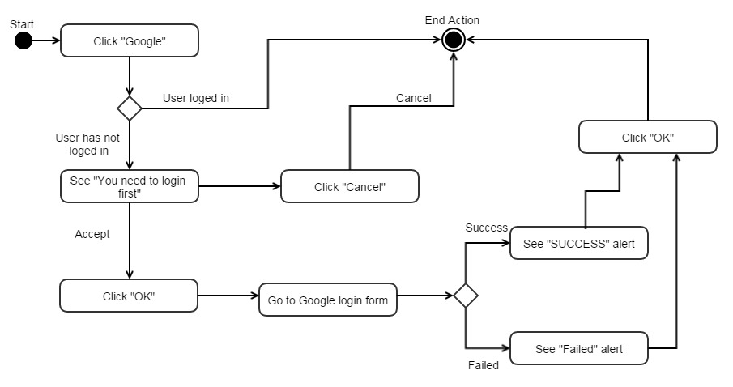

### Log out

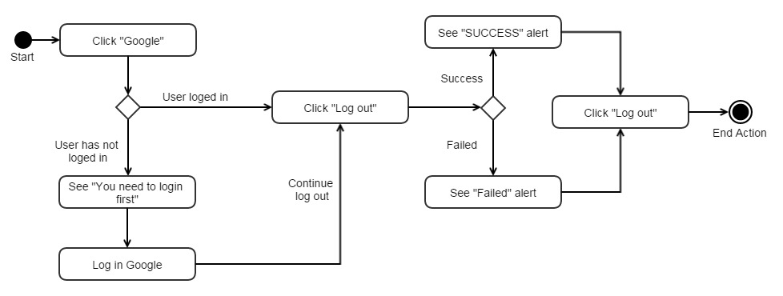

### Update Events

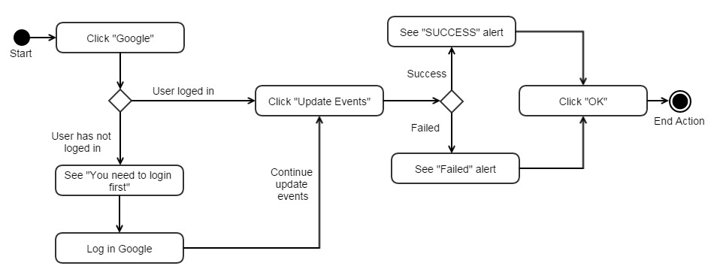

# Share Activity diagram

## Facebook

### Share

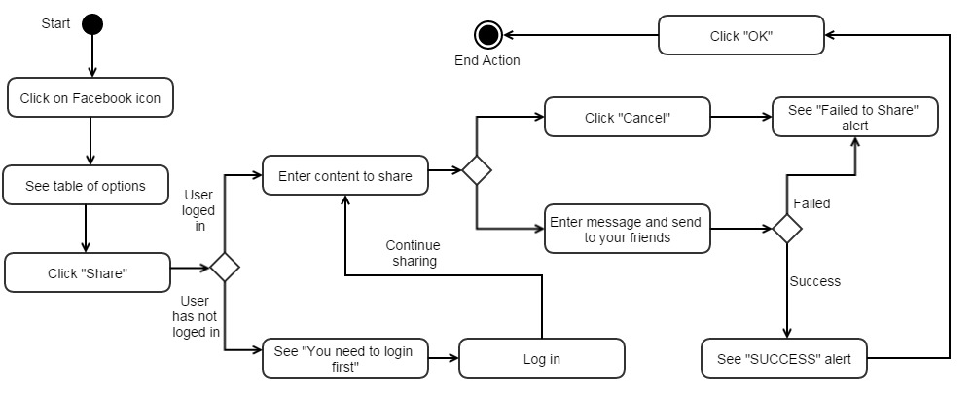

### Send Message

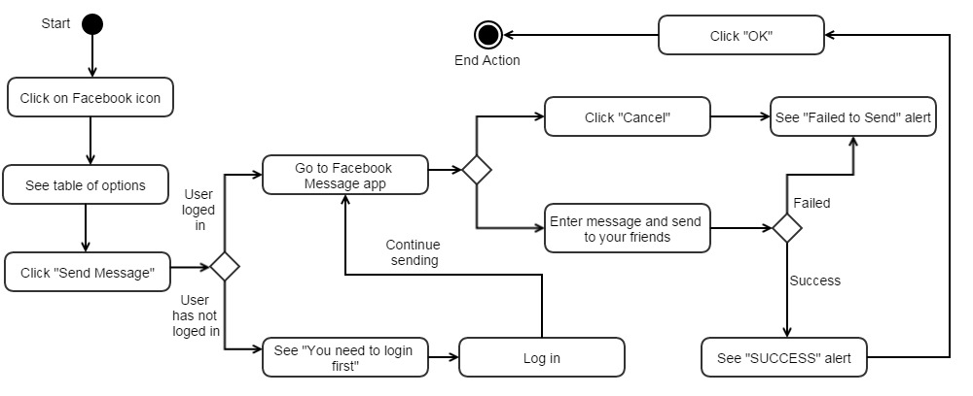

### Log out



# Sign Out Activity diagram

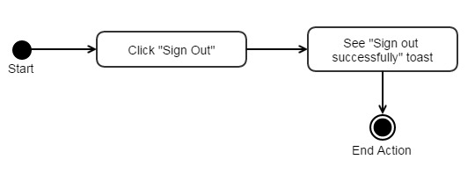

# Refresh Activity diagram

# Exit Activity diagram

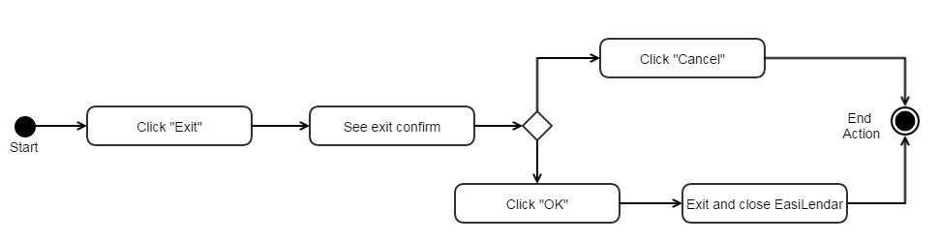

# Calendar Activity diagram

## Calendar Menu

### Change Calendar

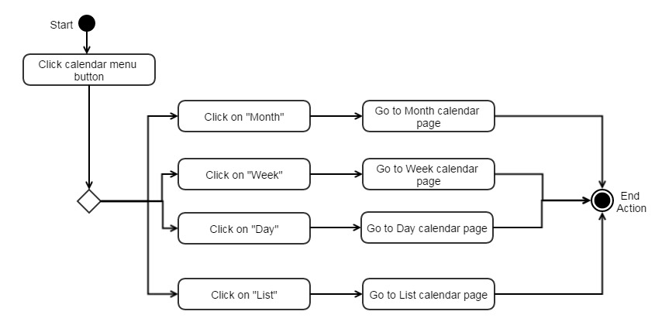

### Go to Today

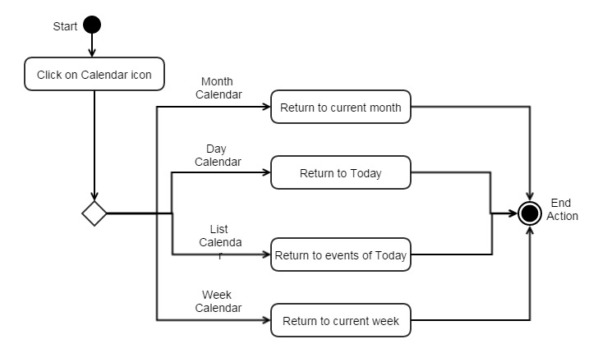

### Search

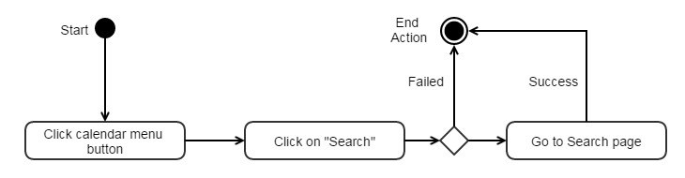

### Create new events

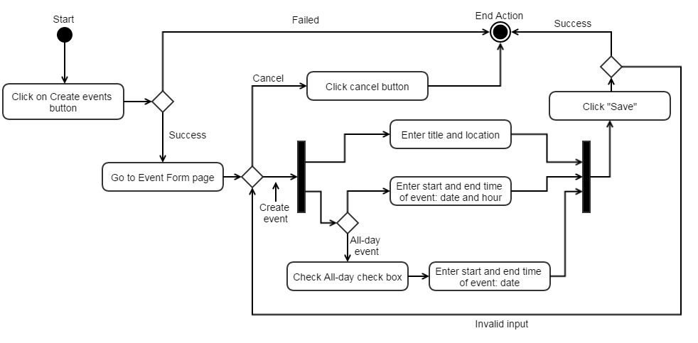

## Day Calendar

### Change day

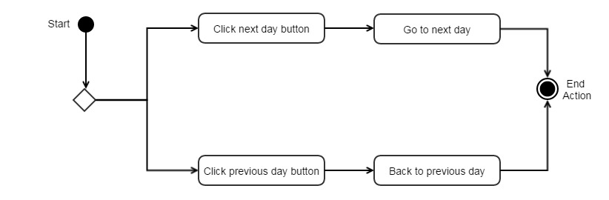

### View event detail

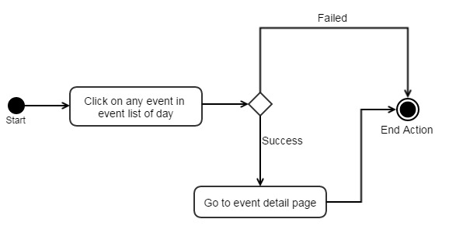

## Month Calendar

### Change month

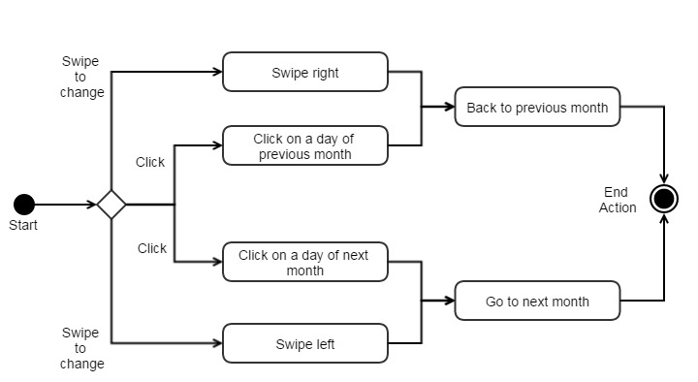

### View event detail

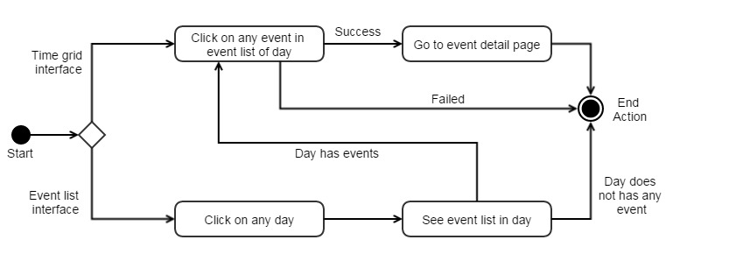

### Table of all months in year

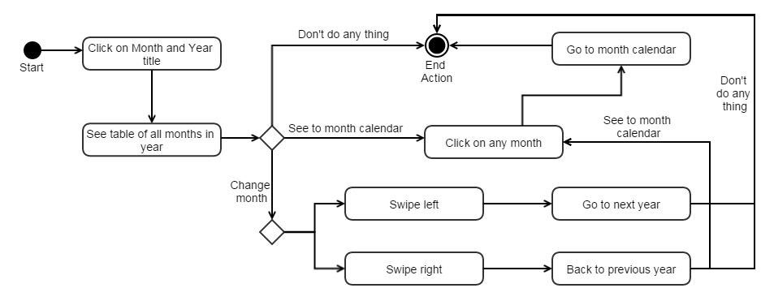

### Create new event

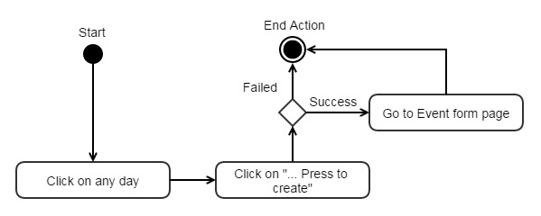

## Week Calendar

### Change week

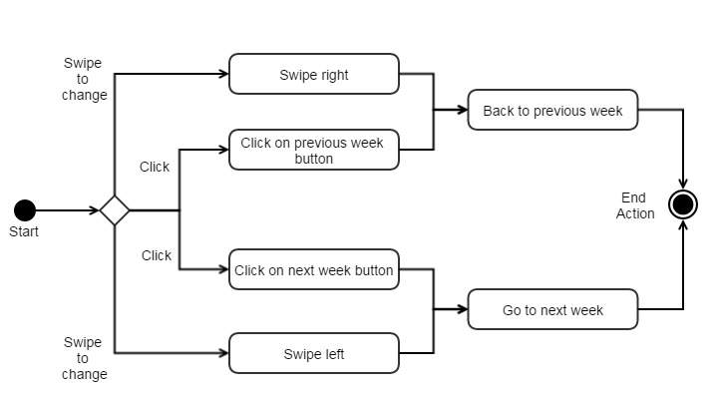

### View event detail

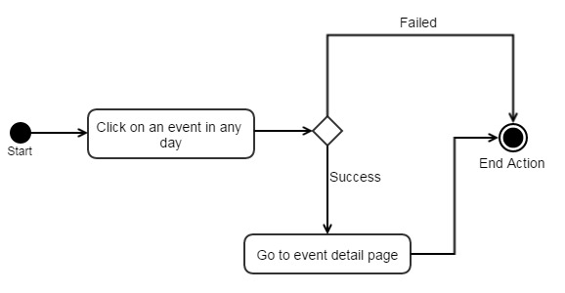

## List Calendar

### Draw week

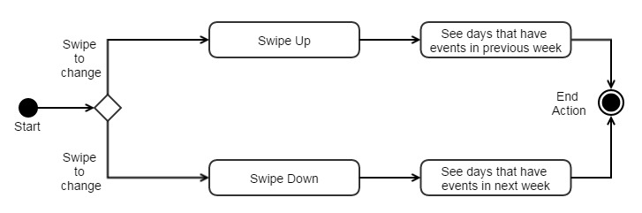

### Create new event

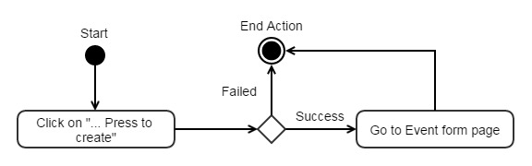

### View event detail

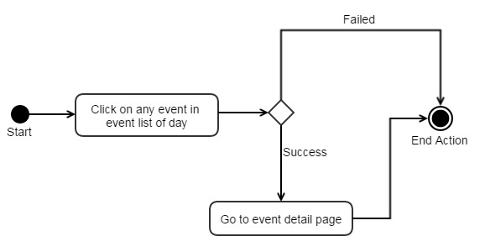

# Edit Event Activity diagram

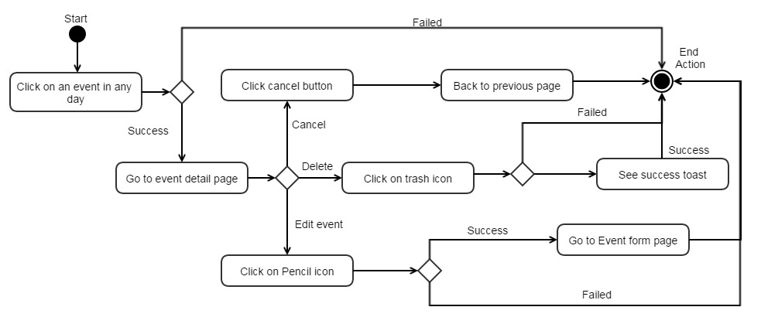

# Notification Activity diagram

## Friend Tab

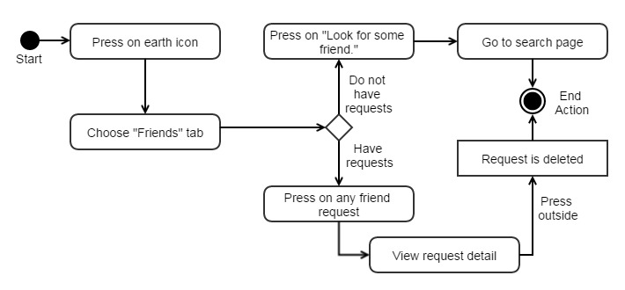

## Request Tab

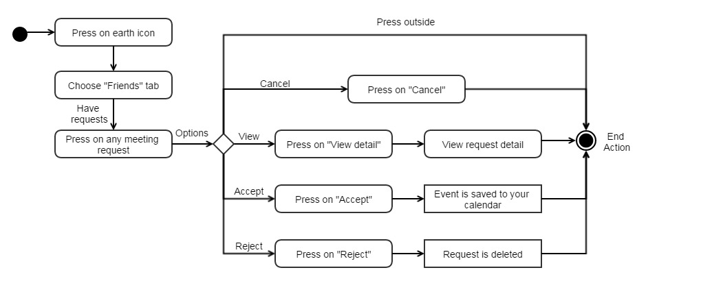

## Respond Tab

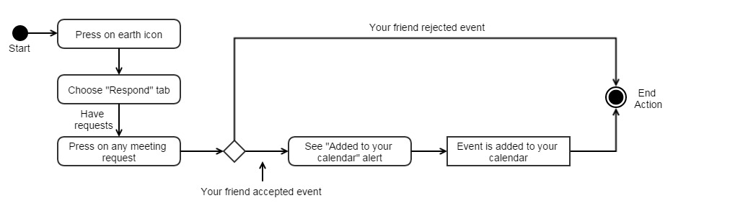

# Friend Panel Activity diagram

## Appointment, Delete and View Profile

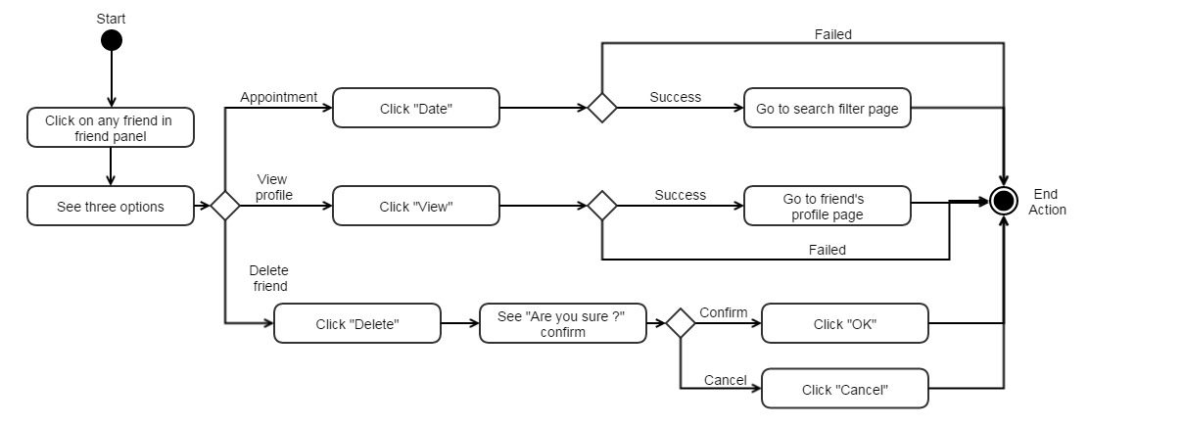

## Sort friend list

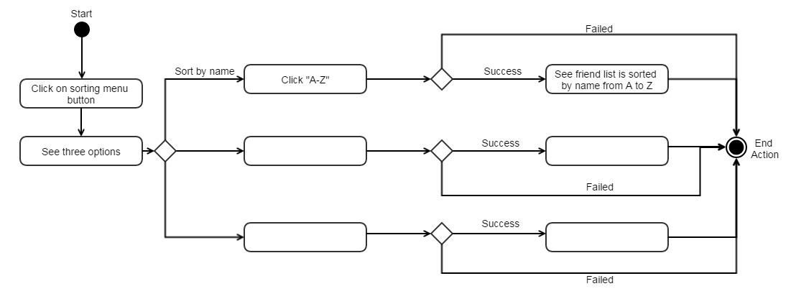

## Search friends and Refresh friend list

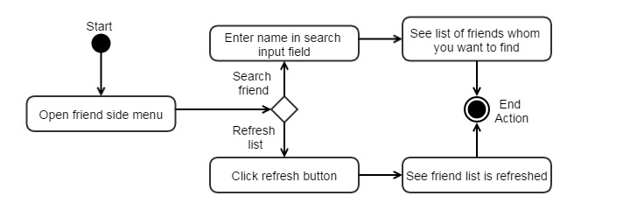

# Result Activity diagram

## Change week

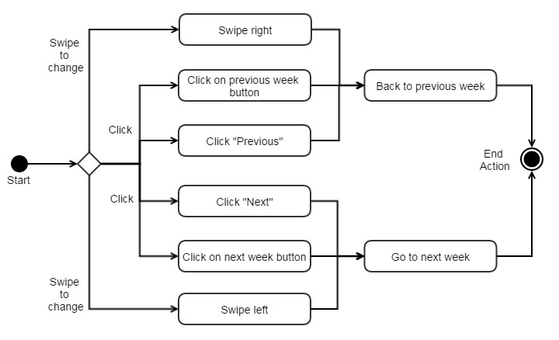

## See other results and view result detail

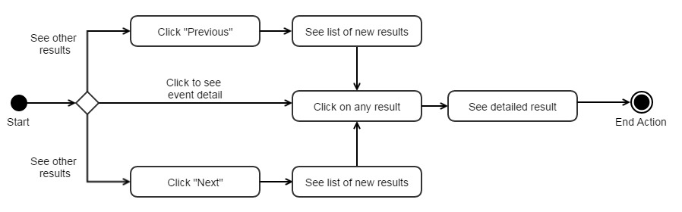

## Back to edit or save results

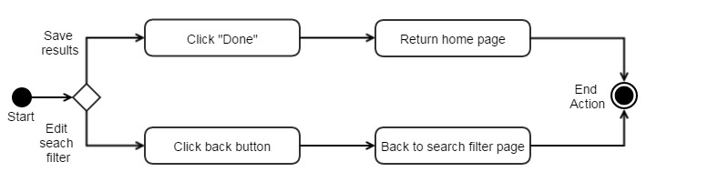

# Profile Activity diagram

## View Profile

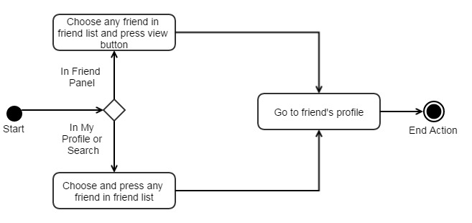

## View Calendar

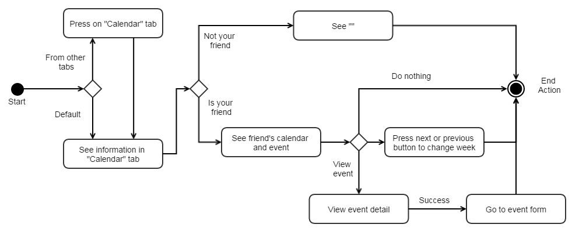

## View Information

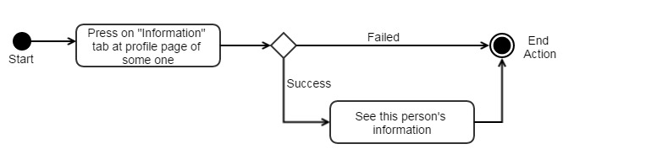

## View Friend List

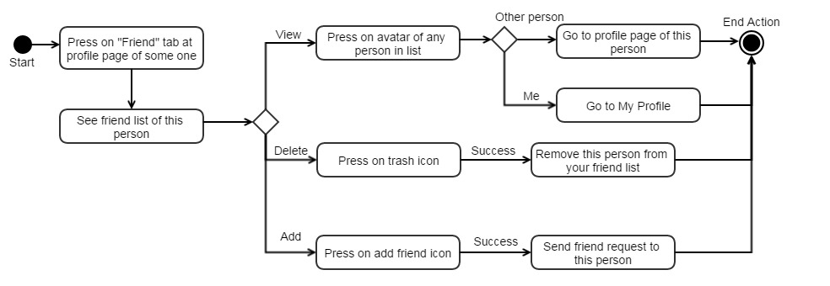

## Date, Delete, Add and Chat

